**Automated Hand With Memory**

**Stepwise Procedure:**

**1. Download and install the Arduino IDE software:**

**Step 1** - First you must have your Arduino board (you can choose your favorite board) and a USB cable.

**Step 2 − Download Arduino IDE Software.**

You can get different versions of Arduino IDE from the [Download page](https://www.arduino.cc/en/Main/Software) on the Arduino Official website. You must select your software, which is compatible with your operating system (Windows, IOS, or Linux). After your file download is complete, unzip the file.

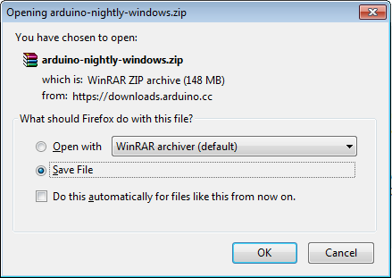

**Step 3 − Power up your board.**

The Arduino Nano, automatically draw power from either, the USB connection to the computer or an external power supply.

**Step 4 − Launch Arduino IDE.**

After your Arduino IDE software is downloaded, you need to unzip the folder. Inside the folder, you can find the application icon with an infinity label (application.exe). Double-click the icon to start the IDE.

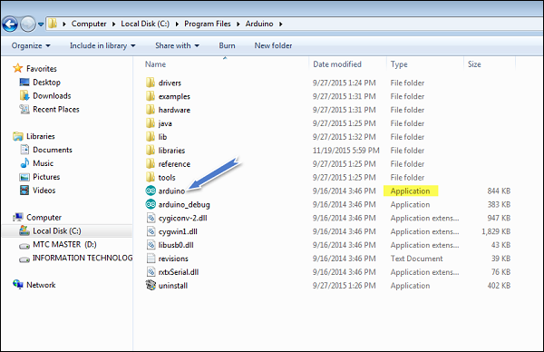

**2. How to Install Arduino Libraries:**

" <https://www.arduino.cc/en/hacking/libraries>" (Link inside the quotes)

The Arduino IDE provides several libraries that can be used to make many projects, but, sometimes, specialized hardware or software is needed. In this tutorial, we will learn how to install extra libraries for our project!

Installing Arduino libraries can be done in three different ways: manually installing the files, importing a ZIP file, and using the library manager. Two of these methods can be done with menu options. But for manual installation, you have to locate the library’s files and place them into the Arduino “libraries” folder.

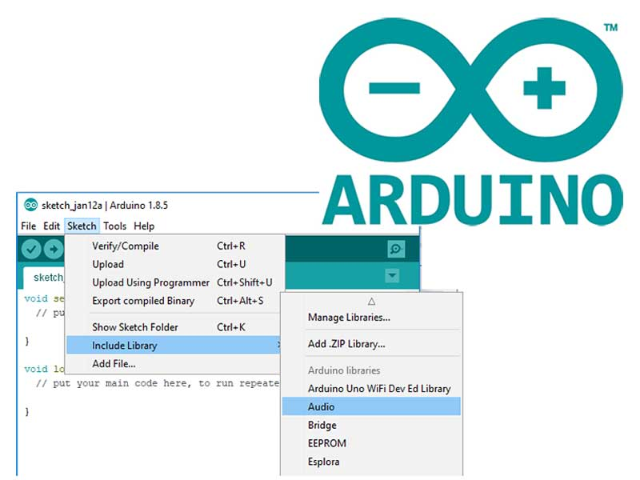

**3. Changing the code as per requirements:**

This step includes some changes in the code as per users requirements i.e. In this syste we need to use the embedded C as per our project requires the inputs through programming language mentioned above.

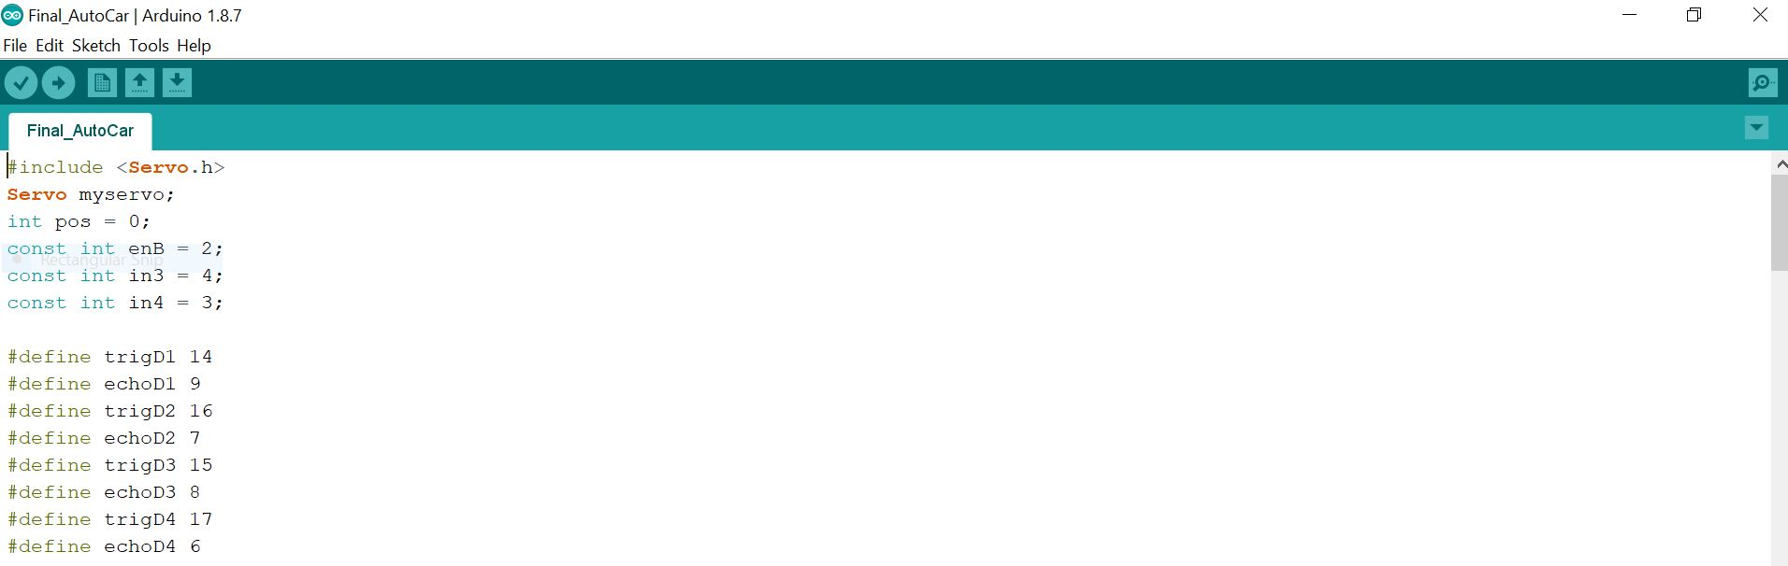

**4. Upload the sketch in the Arduino Uno**

Upload the sketch in Arduino Nano by using USB cable as shown in figure. To upload the sketch use win+R key. Or directly click Upload button.

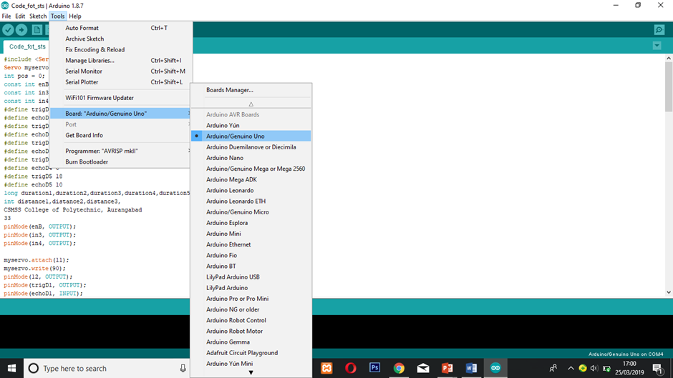

**5. Connect the Components**

Connect the components with each other as shown in the following figure:

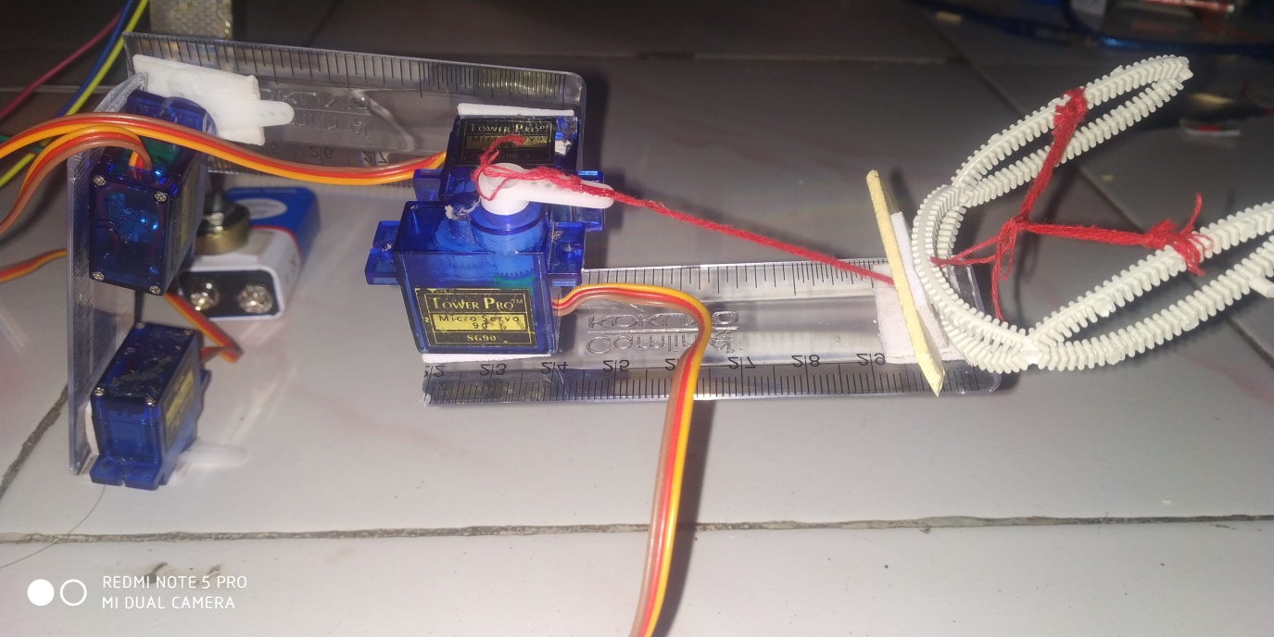

**6. See the result**

**Step 1:** Connect the USB.

**Step 2:** Upload the program.

**Step 3:** To see the output first open serial monitor i.e. Tools >>Serial Monitor.

**Step 4:** Turn on the component switches on of Arduino